10 Steps to Optimize your LinkedIn Profile for Search
by Divya Chandran

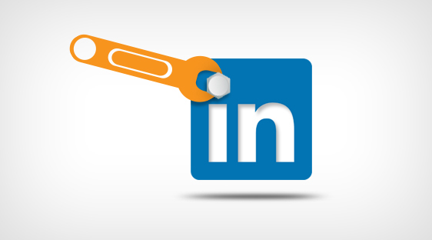
JUL
26
inShare29
We are optimistic about the future, and daydream about next steps. But on some days, job searching is arduous (Read: it often sucks). It’s a vast, wide world in the job market. In this case, it’s vast with competition and wide with confusion.
LinkedIn, a professional social networking site, has become a key player to both prospective employees and employers. It could resolve your never-ending job search for a great career. If you need convincing of LinkedIn’s relevance, here are some figures that are sure to help: LinkedIn has 225 million members and 3 million company profiles, while 88% of Fortune 100 companies heavily use it for recruitment.
With so many companies trusting LinkedIn to help them find talent, job searchers should build compelling cases for themselves through their LinkedIn profiles. This includes content of course, but it also is about search engine optimizing your page so that companies you seek out will be able to find you and consider you a strong candidate. In other words, you want to be found. Speak the language they do so they understand who you are and why they should want you. It’s a lot like dating.
Search Engine Optimization on LinkedIn
A job posting goes up. It’s likely that numerous candidates apply. On the back end, the company is able to use tools like Profile Matcher and Talent Finder, which recommend candidates based on the job criteria, location, and other selected parameters. The words that that candidates use are paramount- if the candidate uses the same descriptors as the company, he or she increases the likelihood of being considered a good, relevant candidate.
To help you succeed in this process here’s a quick and dirty guide with 10 steps to optimize your LinkedIn profile:
  - 1. Create a custom profile URL: Usually, your unique LinkedIn URL will contain gibberish letters and numbers. Change it to your full name - if that’s taken, try recognizable iterations of your name. The goal is to get a URL that is immediately identified as yours.
  - 2. Identify Keywords: Research your desired jobs and make a list of common terms. You can also use Google AdWords Keyword Tool to figure out which terms will increase your searchability.
  - 3. Upload profile picture: Use a high resolution profile picture with a simple background. Your face should be clear even in the small icon size.
  - 4. Be strategic with content: Develop content that tells a comprehensive, consistent story about your career history. Aptly use the keywords found in Step #2 in job descriptions and the “About Me” section. Pay special attention to using keywords in titles- as they will receive higher rankings.
  - 5. Optimize your anchor links: You can add up to 3 of your own websites to LinkedIn. When it asks you for “Type,” choose “Other” and use keywords to describe it.
  - 6. Complete your profile: That means all fields are 100% complete. The more fields filled, the more views you get. Just in case you were shying away from getting it done, yes, you must do your “About Me” section. I didn’t want to do it either, but it’s definitely worth your time.
  - 7. Upload samples of your work: If you have videos/presentations/publications that qualify your expertise, share it. Here’s how.
  - 8. Group membership: Ideally, you’ll join relevant groups to participate for idea transfer. Realistically, you should definitely join groups to increase your search engine hit rates. I encourage participation in groups because companies actively scout potential hires in forums.
  - 9. Recommendations: Reach out to past and present colleagues for reviews. It may feel strange (“Hey, can you publicly flatter me?”), but what must be done must be done. The likelihood is that more often than not they will be happy that you sought out their input.
  - 10. Interact: Expand your network. Participate in groups. Make yourself prominent. Building a great profile and then abandoning it is just plain silly. Use it even after you get that dream job so you stay current.
With follow through on these steps, you’ll likely receive more views and interaction. Good luck on your job search!
Have any questions or comments about how to optimize your LinkedIn profile to make your job search easier? Leave a comment below or tweet us @BFMWeb.
- See more at: http://www.bluefountainmedia.com/blog/quick-and-dirty-guide-to-seo-optimizing-your-linkedin-profile/#sthash.zWTlVoBk.dpuf

